Southern Ocean

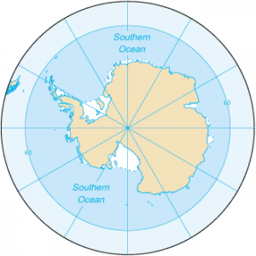

southernocean.png

The Southern Ocean, also known as the Antarctic Ocean, is one of the Earth's five major oceans and surrounds the continent of Antarctica. It is unique in several ways and plays a crucial role in global climate systems. Due to its unique characteristics and importance in climate systems, the Southern Ocean is a focus of scientific research. Researchers study the region's marine life, ice dynamics, and its role in regulating Earth's climate.

Examole of marine life :

1. Krill

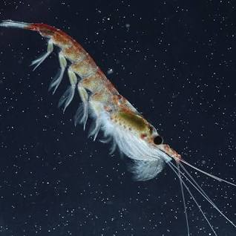

krill_creaturesinsouthernocean.png

1. Antarctic Toothfish

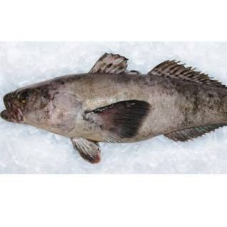

antarctictoothfish_creaturesinsouthernocean.png

1. Sea Spiders

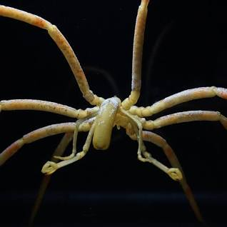

seaspider_creaturesinsouthernocean.png